**DAY 9**

**EX 01:**

package day9;

import org.testng.annotations.Test;

import org.testng.Assert;

import org.testng.annotations.DataProvider;

public class d9project1 {

int a,b,c;

@Test(dataProvider = "dp")

public void add(Integer a,Integer b) {

c=a+b;

System.out.println("Sum:"+c);

Assert.assertEquals(c,15);

}

@Test(dataProvider = "dp")

public void sub(Integer a,Integer b) {

c=a-b;

System.out.println("Difference:"+c);

Assert.assertEquals(c, 5);

}

@Test(dataProvider = "dp")

public void multiply(Integer a,Integer b) {

c=a*b;

System.out.println("Product:"+c);

Assert.assertEquals(c, 50);

}

@Test(dataProvider = "dp")

public void divide(Integer a,Integer b) {

c=a/b;

System.out.println("Quotient:"+c);

Assert.assertEquals(c, 2);

}

@DataProvider

public Object[][] dp() {

return new Object[][] {

new Object[] { 10, 5 },

new Object[] { 12, 6},

};

}

}

**OUTPUT:**

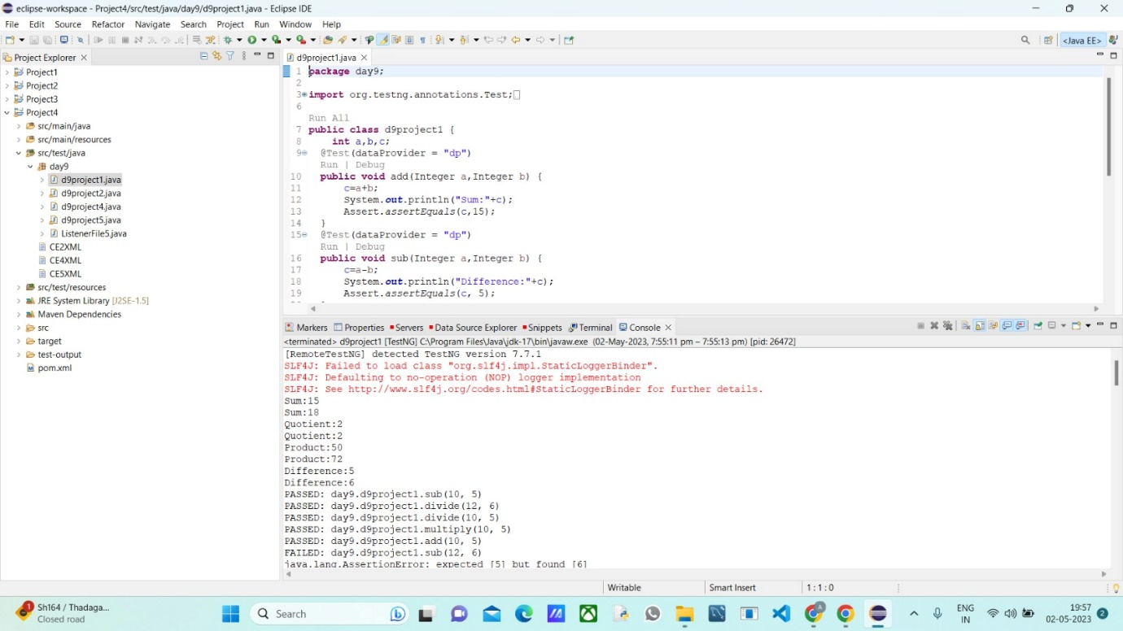

**EX 2 AND 3:** **package day9;**

import org.testng.annotations.Test;

import com.google.common.base.Verify;

import io.github.bonigarcia.wdm.WebDriverManager;

import java.util.concurrent.TimeUnit;

import org.openqa.selenium.By;

import org.openqa.selenium.WebDriver;

import org.openqa.selenium.WebElement;

import org.openqa.selenium.chrome.ChromeDriver;

import org.openqa.selenium.chrome.ChromeOptions;

import org.testng.Assert;

import org.testng.annotations.DataProvider;

public class d9project2{

@Test

public void Testcase01() {

WebDriverManager.chromedriver().setup();

ChromeOptions ed= new ChromeOptions();

WebDriver driver=new ChromeDriver(ed);

driver.get("https://www.godaddy.com");

driver.manage().window().maximize();

Assert.assertEquals(driver.getTitle(),"Domain Names, Websites, Hosting & Online Marketing Tools - GoDaddy IN");

Assert.assertEquals(driver.getCurrentUrl(),"https://www.godaddy.com/en-in" );

}

@Test

public void Testcase02() {

WebDriverManager.chromedriver().setup();

ChromeOptions ed= new ChromeOptions();

WebDriver driver=new ChromeDriver(ed);

driver.get("https://www.godaddy.com");

driver.manage().window().maximize();

driver.manage().timeouts().implicitlyWait(5, TimeUnit.SECONDS);

driver.findElement(By.xpath("//*[@id=\"id-631b049a-e9c0-4d24-8710-c504745206dd\"]/div[2]/div[1]/ul/li[1]/button")).click();

try {

Thread.sleep(2000);

} catch (InterruptedException e) {

// TODO Auto-generated catch block

e.printStackTrace();

}

driver.findElement(By.xpath("//*[@id=\"id-631b049a-e9c0-4d24-8710-c504745206dd\"]/div[2]/div[1]/ul/li[1]/div/div[2]/div[1]/ul/li[2]/a")).click();

}

@Test

public void Testcase03() {

WebDriverManager.chromedriver().setup();

ChromeOptions ed= new ChromeOptions();

WebDriver driver=new ChromeDriver(ed);

driver.get("https://www.godaddy.com");

driver.manage().window().maximize();

driver.manage().timeouts().implicitlyWait(5, TimeUnit.SECONDS);

driver.findElement(By.xpath("//*[@id=\"id-631b049a-e9c0-4d24-8710-c504745206dd\"]/div[2]/div[1]/ul/li[1]/button")).click();

try {

Thread.sleep(2000);

} catch (InterruptedException e) {

// TODO Auto-generated catch block

e.printStackTrace();

}

driver.findElement(By.xpath("//*[@id=\"id-631b049a-e9c0-4d24-8710-c504745206dd\"]/div[2]/div[1]/ul/li[1]/div/div[2]/div[1]/ul/li[2]/a")).click();

try {

Thread.sleep(4000);

} catch (InterruptedException e) {

// TODO Auto-generated catch block

e.printStackTrace();

}

System.out.println(driver.getTitle());

if(driver.getTitle().equals("GoDaddy Domain Search - Buy and Register Available Domain Names")) {

WebElement search= driver.findElement(By.name("searchText"));

System.out.println(search.isDisplayed());

System.out.println(search.isEnabled());

WebElement buyit=driver.findElement(By.xpath("//*[@id=\"id-1467954b-c5e3-4b0c-9046-9fc94d8ca892\"]/section/div/div/section/div/div[1]/div/div/div[2]/button"));

System.out.println(buyit.isDisplayed());

System.out.println(buyit.isEnabled());

search.sendKeys("monkyhomie");

try {

Thread.sleep(2000);

} catch (InterruptedException e) {

// TODO Auto-generated catch block

e.printStackTrace();

}

buyit.click();

try {

Thread.sleep(6000);

} catch (InterruptedException e) {

// TODO Auto-generated catch block

e.printStackTrace();

}

// Assert.assertEquals(driver.findElement(By.xpath("//*[@id=\"search-app\"]/div/div/div/div[2]/div[1]/div[2]/div[1]/div[2]/div/div[1]/span")).getText(),"EXACT MATCH");

//Verify.verify((driver.findElement(By.xpath("//*[@id=\"search-app\"]/div/div/div/div[2]/div[1]/div[2]/div[1]/div[2]/div/div[4]/div/div/div/div[2]/button")).getText()).equals("Add to Cart"));

//Verify.verify(driver.findElement(By.xpath("//*[@id=\"search-app\"]/div/div/div/div[2]/div[1]/div[2]/div[1]/div[2]/div/div[3]/div/div[1]/div[1]/div/span[1]/span")).isDisplayed());

}

else Assert.assertTrue(false);

}

}

**OUTPUT:**

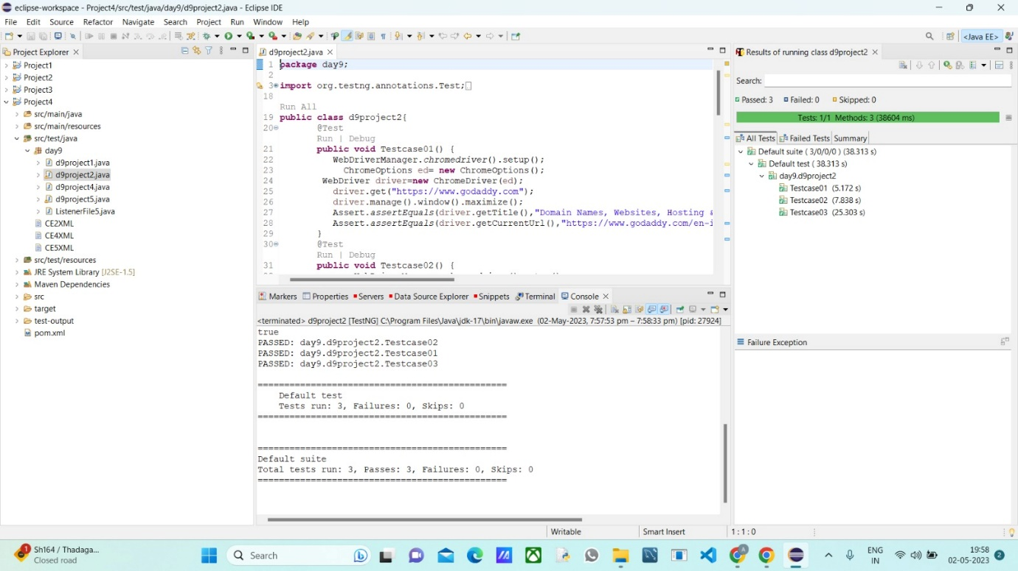

**EX 04:**

package day9;

import org.openqa.selenium.By;

import org.openqa.selenium.WebDriver;

import org.openqa.selenium.WebElement;

import org.openqa.selenium.chrome.ChromeDriver;

import org.openqa.selenium.chrome.ChromeOptions;

import org.openqa.selenium.edge.EdgeDriver;

import org.testng.Assert;

import org.testng.annotations.AfterMethod;

import org.testng.annotations.BeforeMethod;

import org.testng.annotations.Parameters;

import org.testng.annotations.Test;

import org.openqa.selenium.edge.EdgeOptions;

import org.openqa.selenium.firefox.FirefoxOptions;

import org.openqa.selenium.firefox.FirefoxDriver;

import io.github.bonigarcia.wdm.WebDriverManager;

public class d9project4 {

WebDriver driver;

@Test

public void f() throws InterruptedException {

Thread.sleep(3000);

WebElement na=driver.findElement(By.xpath("//*[@id=\"app\"]/div[1]/div/div[1]/div/div[2]/div[2]/form/div[1]/div/div[2]/input"));

na.sendKeys("Admin");

Thread.sleep(1000);

WebElement naa=driver.findElement(By.name("password"));

naa.sendKeys("admin123");

Thread.sleep(1000);

WebElement bta=driver.findElement(By.xpath("//*[@id=\"app\"]/div[1]/div/div[1]/div/div[2]/div[2]/form/div[3]/button"));

bta.click();

Thread.sleep(3000);

String url="https://opensource-demo.orangehrmlive.com/web/index.php/dashboard/index";

Assert.assertEquals(url,driver.getCurrentUrl());

}

@Parameters({"browser"})

@BeforeMethod

public void setup(String brows) {

if(brows.equals("chrome")) {

WebDriverManager.chromedriver().setup();

ChromeOptions co=new ChromeOptions();

co.addArguments("--remote-allow-origins=*");

// co.addArguments("start-maximized");

driver=new ChromeDriver(co);

driver.get("https://opensource-demo.orangehrmlive.com/web/index.php/auth/login");

driver.manage().window().maximize();

}

else if(brows.equals("edge")) {

WebDriverManager.edgedriver().setup();

EdgeOptions co=new EdgeOptions();

co.addArguments("--remote-allow-origins=*");

// co.addArguments("start-maximized");

driver=new EdgeDriver(co);

driver.get("https://opensource-demo.orangehrmlive.com/web/index.php/auth/login");

driver.manage().window().maximize();

}

else if(brows.equals("firefox")) {

WebDriverManager.firefoxdriver().setup();

FirefoxOptions co=new FirefoxOptions();

co.addArguments("--remote-allow-origins=*");

// co.addArguments("start-maximized");

driver=new FirefoxDriver(co);

driver.get("https://opensource-demo.orangehrmlive.com/web/index.php/auth/login");

driver.manage().window().maximize();

}

}

@AfterMethod

public void teardown() throws InterruptedException {

Thread.sleep(4000);

driver.close();

}

}

**OUTPUT:**

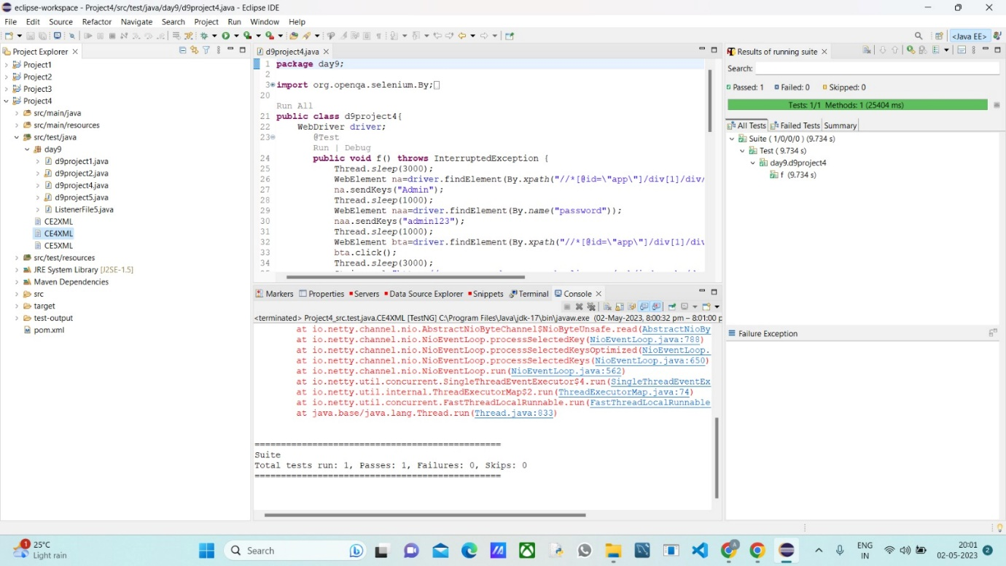

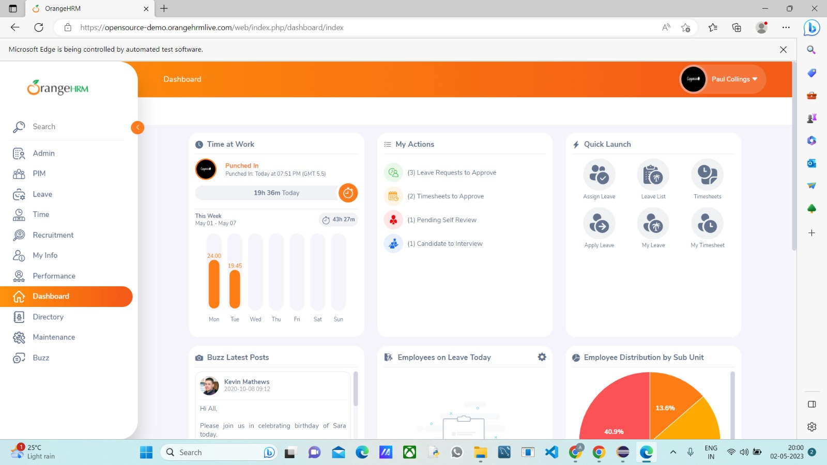

**EX 05:**

**TESTNG FILE:**

package day9;

import org.openqa.selenium.By;

import org.openqa.selenium.WebDriver;

import org.openqa.selenium.WebElement;

import org.openqa.selenium.chrome.ChromeDriver;

import org.openqa.selenium.chrome.ChromeOptions;

import org.openqa.selenium.edge.EdgeDriver;

import org.openqa.selenium.edge.EdgeOptions;

import org.testng.Assert;

import org.testng.annotations.AfterMethod;

import org.testng.annotations.BeforeMethod;

import org.testng.annotations.Parameters;

import org.testng.annotations.Test;

import io.github.bonigarcia.wdm.WebDriverManager;

public class d9project5 {

WebDriver driver;

@Test

public void f() throws InterruptedException {

Thread.sleep(3000);

WebElement na=driver.findElement(By.xpath("//*[@id=\"app\"]/div[1]/div/div[1]/div/div[2]/div[2]/form/div[1]/div/div[2]/input"));

na.sendKeys("Admin");

Thread.sleep(1000);

WebElement naa=driver.findElement(By.name("password"));

naa.sendKeys("admin123");

Thread.sleep(1000);

WebElement bta=driver.findElement(By.xpath("//*[@id=\"app\"]/div[1]/div/div[1]/div/div[2]/div[2]/form/div[3]/button"));

bta.click();

Thread.sleep(3000);

String url="https://opensource-demo.orangehrmlive.com/web/index.php/dashboard/index";

Assert.assertEquals(url,driver.getCurrentUrl());

}

@BeforeMethod

public void setup() {

WebDriverManager.chromedriver().setup();

ChromeOptions co=new ChromeOptions();

co.addArguments("--remote-allow-origins=*");

// co.addArguments("start-maximized");

driver=new ChromeDriver(co);

driver.get("https://opensource-demo.orangehrmlive.com/web/index.php/auth/login");

driver.manage().window().maximize();

}

@AfterMethod

public void teardown() throws InterruptedException {

Thread.sleep(4000);

driver.close();

}

}

**LISTENER FILE**:

package day9;

import org.testng.ITestContext;

import org.testng.ITestListener;

import org.testng.ITestResult;

public class Listenerfileday5 implements ITestListener{

public void onTestStart(ITestResult result) {

// TODO Auto-generated method stub

System.out.println("onTestStart"+result.getName());

}

public void onTestSuccess(ITestResult result) {

// TODO Auto-generated method stub

System.out.println("onTestSuccess"+result.getName());

}

public void onTestFailure(ITestResult result) {

// TODO Auto-generated method stub

System.out.println("onTestFailure"+result.getName());

}

public void onTestSkipped(ITestResult result) {

// TODO Auto-generated method stub

System.out.println("onTestSkipped"+result.getName());

}

public void onTestFailedButWithinSuccessPercentage(ITestResult result) {

// TODO Auto-generated method stub

System.out.println("onTestFailedButWithinSuccessPercentage"+result.getName());

}

public void onTestFailedWithTimeout(ITestResult result) {

// TODO Auto-generated method stub

System.out.println("onTestFailedWithTimeout"+result.getName());

}

public void onStart(ITestContext context) {

// TODO Auto-generated method stub

System.out.println("onStart"+context.getName());

}

public void onFinish(ITestContext context) {

// TODO Auto-generated method stub

System.out.println("onFinish"+context.getName());

}

}

**OUTPUT:**

